Governance
PSTC is operated by its constitutionally approved governance structure. Different levels of functionary bodies make PSTC effective as per its policies, guidelines, mandates and approved constitutions.

Governing Body
A seven-member Governing Body (GB) elected by the general body works actively for setting up the standards and reviewing the overall policy guideline of the organization. The GB members oversee the implementation of the ongoing activities of the organization on a regular basis.
The Executive Director, who is also the ex-officio Member-Secretary of the GB, is responsible for overall implementation of the PSTC programs and projects. The ED is joined by Top Management Team (TMT) and a group of qualified and experienced professionals to run the programs and projects undertaken by PSTC.

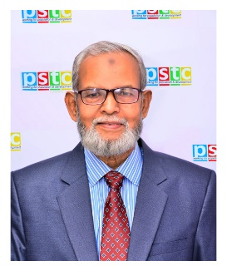

Mr. Mosleh Uddin Ahmed
Chairperson

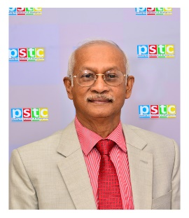  Dr. Md. Golam Rahman  Vice-Chairperson | 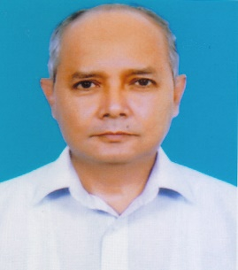  Mr. Md. Badrul Munir  Treasurer
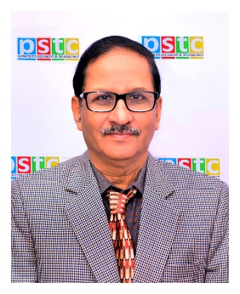  Mr. Kazi Ali Reza  Member | 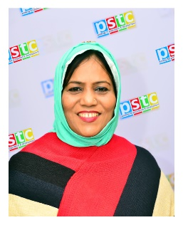  Mrs. Lulu Bilkis Khanom  Member
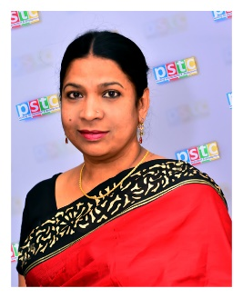  Mrs. Gitali Badrunnessa  Member | 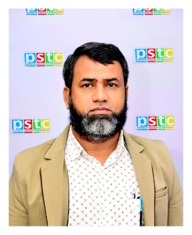  Professor Belal Ahmed  Member

